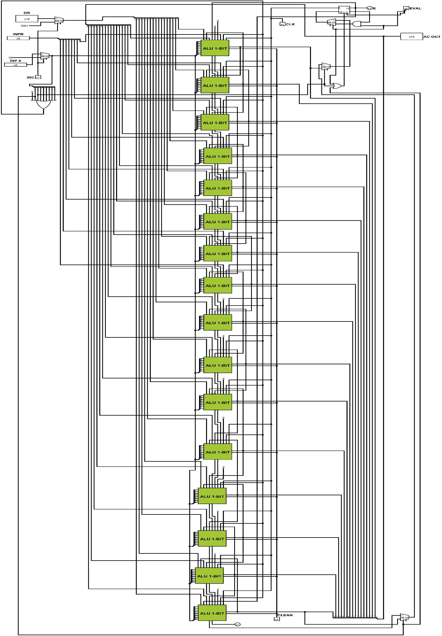

**Implementation of 16 – BIT ALU**

**Implementation of CONTROL UNIT**

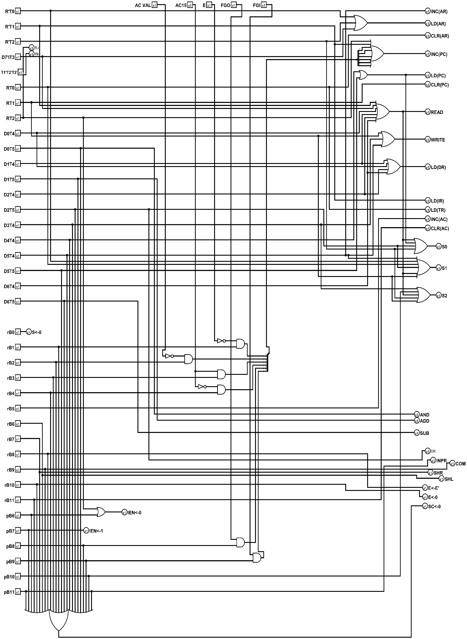

**Implementation of MEMORY REFERANCE**

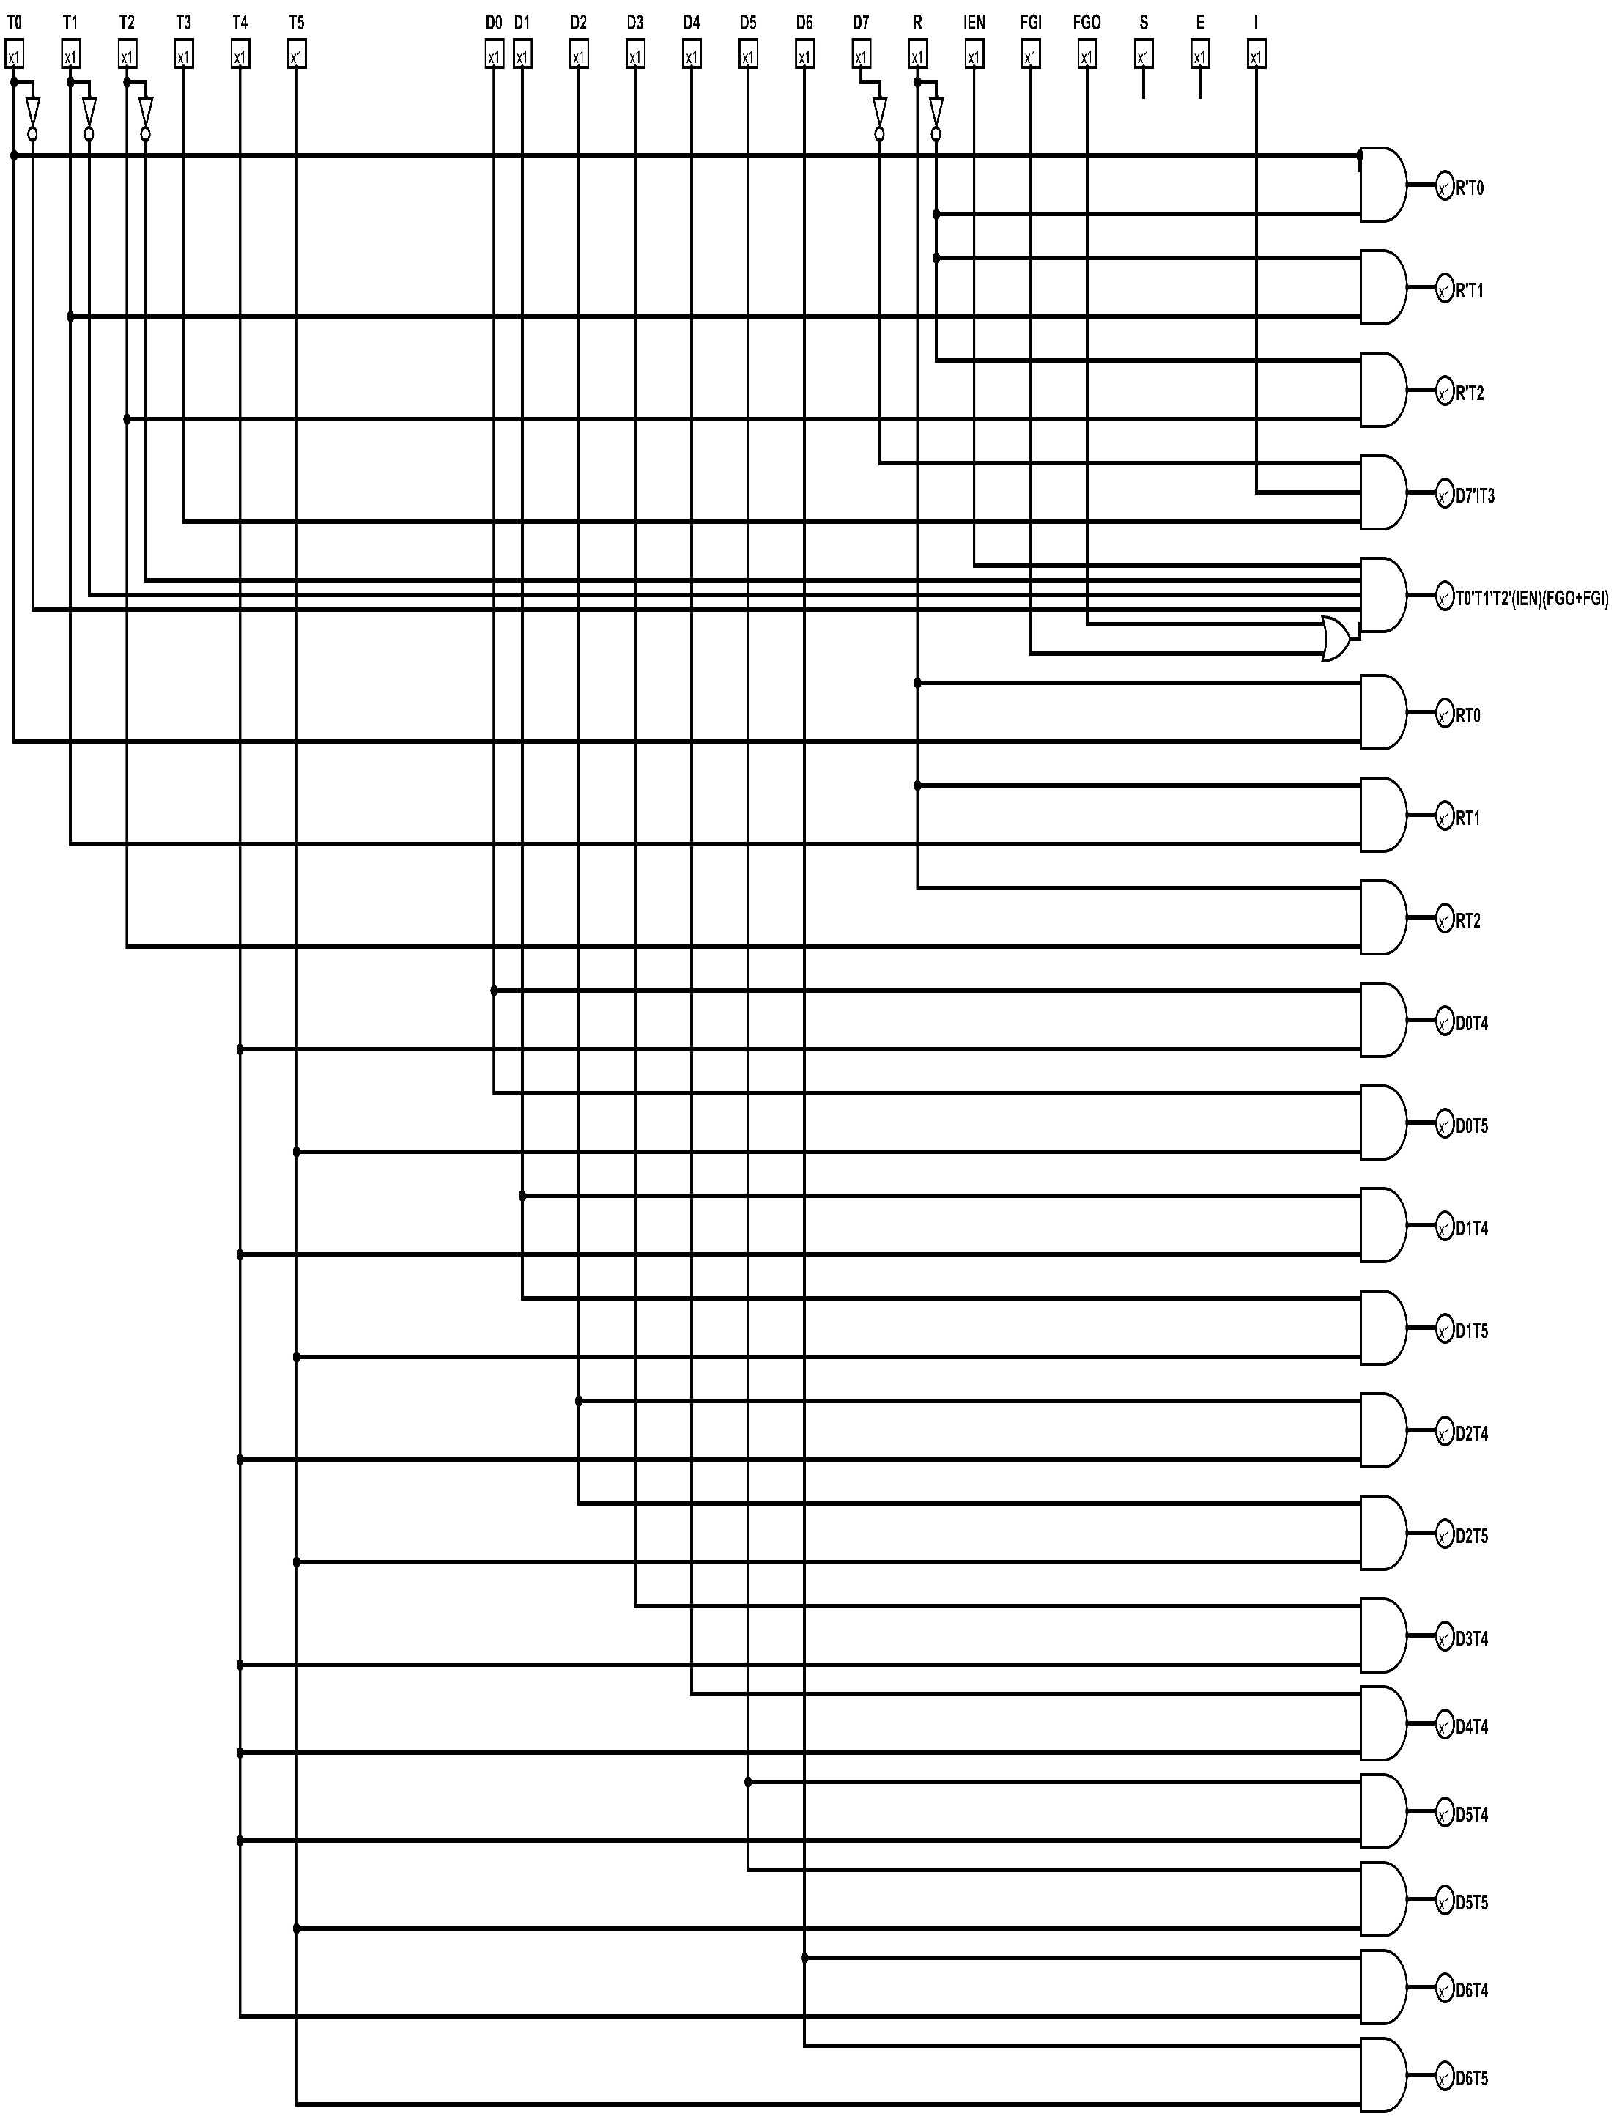

**COMPUTER – 1 MAIN CIRCUIT**

